Personal Finance Career Choice?
Name:
Class ID:
Class Hour:
Chapter 1, Career Choice

Objectives

What are the types of Work
Four Types of Pay
How you are Paid

Types of Work:

Employment Types
Full Time | Part time
Definition  Key Facts:  Mandatory Benefits  Voluntary Benefits | Definition:  Key Facts:

Compensation Types
Paid | Unpaid
Three Types of Income:
1
2
3

From the slide graphic, insert the three types, their Definition, and list the types of Income that each can be

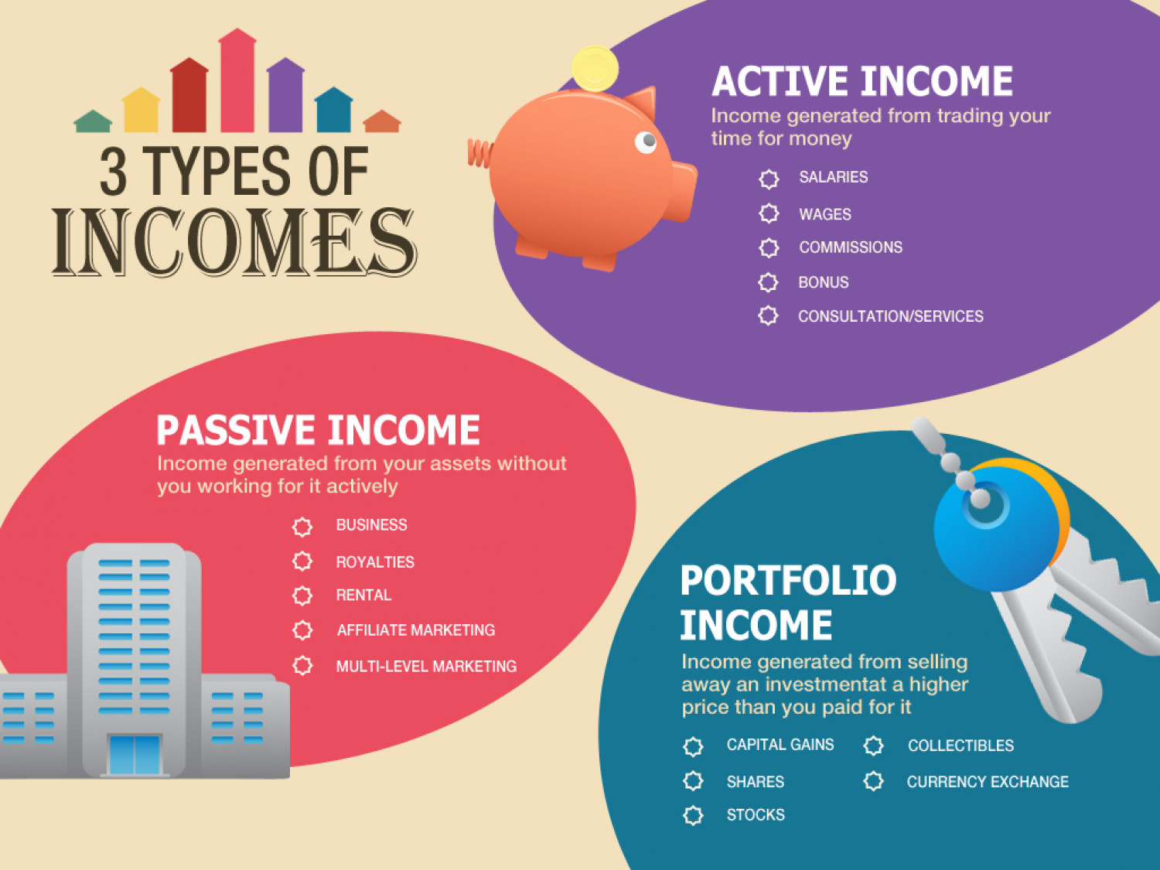

4 Common Types of Pay:
List each type at the left, then provide some details at that right.

List and Define | Key Element Here:
1. | Exempt employee:
2. | AKA:  Non-Exempt means:  Overtime Pay:
3. | Common Types:  Discretionary  Non Discretionary:
4. | Straight Commission  Base Pay Commission

Minimum Wage (definition):

Complete the assignment on Minimum wage on google classroom. Enter the answers to the following questions:

- What is the minimum wage for the US?
- Does every state have the same minimum wage?
- What is the minimum wage for ND?
- Is the minimum wage the same for every single type of Job?
How are You Paid?

Calculate Your Wage Practice:

Question: | Answer
If you are paid a salary of $48,000 being paid bi-monthly what is your gross wage per check?
If you were paid a salary of $48,000 and paid weekly, what is your gross wage for each check?
If you work full time at $15 an hour. What is your gross wage for 40 hours
If you get paid every two weeks and work 40 hours per week at $10
If you are getting paid bi-weekly working 40 hours per week for $10 per hour, what is your annual wage?
You Earn commission at 3% for selling a house for $350,000
You Earn a base salary of $15 and hour with 3% commission, you worked 40 hours, sold $6,000 in product for the wee.

Type of Unpaid Work

- Volunteer:

- Intern:

Quick Write Activity: Based on what you’ve learned, what type of work do you think you are currently most interested in?
- Full-Time vs Part-Time?
- Paid vs Unpaid and do you want an hourly wage or salary?
- If unpaid, as a volunteer or intern?
- Why do you feel that way?

Chapter 1 – 2: Researching a Career

Objectives:
Difference between a job and a career.
Steps to selecting a Career
How to Research a Career

Why is career Choice Important? List several reasons:

Did you know Vidoe: you will spend over of your lifetime at work. This equates to over hours of time dedicated to working. By the age of 30, most people have had jobs and of workers hate or dislike their jobs.

What do Careers Look Like in the Future:

How to Select a Career:

1 Assess Yourself

2 List Occupations you
may explore

- Explore your list of Career Options | Three US Gov. Publications to use to research:  Occupational Outlook Handbook:  O*NET: Dictional of Occupational Titles (DOT):
4 Choose and Develop a Career Plan

